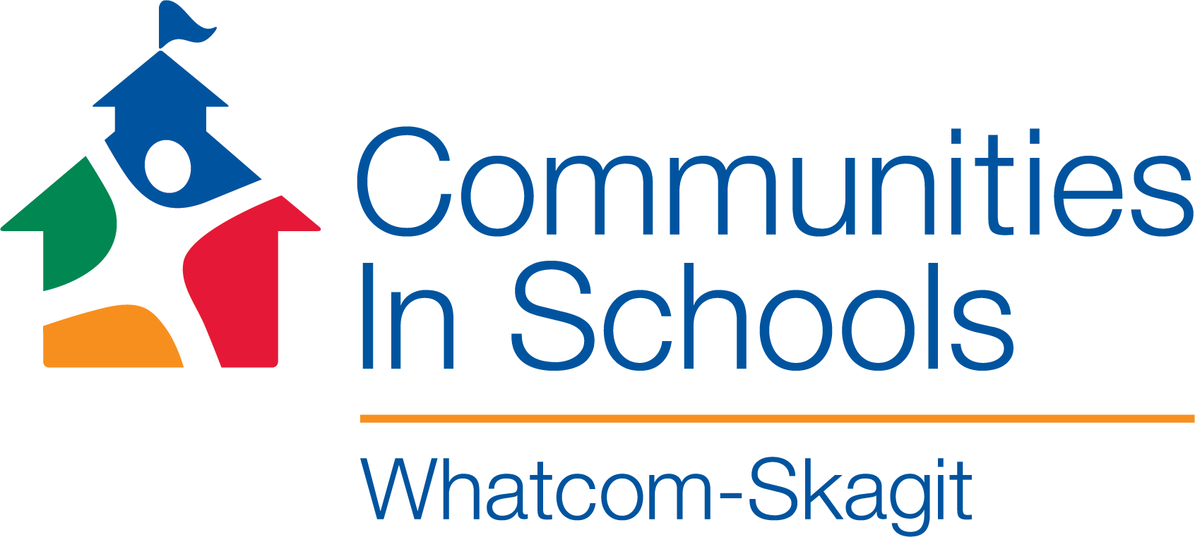
Skagit County McKinney Vento and Out-Of-School Youth Navigator
Communities In Schools of Whatcom-Skagit
Our mission is to surround students with a community of support,
empowering them to stay in school and achieve in life.
Overview
In coordination with the Skagit County Public Health Department and the Mount Vernon School District, Communities In Schools of Whatcom-Skagit is seeking a dynamic community advocate and youth development leader with exceptional initiative, who has a passion to build powerful relationships with youth and families, and the ability to steer the delivery of multiple projects and services in Mount Vernon & across Skagit County.

Location: Mount Vernon High School/ Partnering Skagit County School Districts
Reports to: CIS of Whatcom-Skagit Program Manager, M.V. School Principal & Executive Director
Hours: 40 Hours/week; year-round (unpaid summer time off available upon request). Up to two (optional) weeks off over school breaks. Occasional evening work included.
Wage: $17.50-$20.00 hourly (non-exempt); DOE
Benefits: Wellness Stipend ($450.00 monthly towards a Marketplace plan of your choice); Vacation & Sick Time, & Holidays
Supervision: This position does not supervise other CIS or School District staff/ May supervise volunteers
Collaborates with: Community partners; MV High School Administrators; Communications & Development Director (CIS)
Description: The McKinney Vento/Out-of-School Youth Navigator will work in partnership with school Administrators, Student Support Teams, and other community partners within Mount Vernon High School (and across Skagit County) to ensure that homeless children and school-age youths are enrolled in school, and have full and equal opportunity to succeed academically or complete graduation. Once the McKinney Vento or Out-Of-School student is enrolled, the Navigator will identify additional readiness-to-learn supports needed, and will coordinate with school staff strategies and approaches to meet those critical needs. The Navigator acts as a liaison and/or broker to the resources necessary to improve academics and attendance, increase student resilience, school-bonding, and to increase positive behavior. The Navigator supports students’ whole self, determining individual supports that will meet the needs of each unique student. To that end the Navigator provides confidential, developmentally appropriate, and culturally competent interventions, services and supports to students and families. This position also works in partnership with community partners and other agencies to assure additional resources are available for students and families.

Covid-19 Protocols:
Per current COVID-19 safety and social distancing requirements, the work of the Navigator may be performed (fully or partially) via online platforms and/or tele-working, until vaccinated. As a matter of personal, family, and community health, all CIS of Whatcom-Skagit employees are expected to be vaccinated against Covid-19.
Responsibilities Include:
School-based Services
- Identifies and assists homeless and/or Out-Of-School students in Mount Vernon and collaborating school districts in Skagit County.
- Speaks to community organizations, emphasizing the need to coordinate efforts with homeless outreach programs in Skagit County.
- Works with McKinney Vento and/or Homeless Liaison within the Mount Vernon School District (and other partnering districts) when coordinating services and identifying resources.
- Promotes school and community partnerships.
- Contacts parents to discuss student's progress, promoting parent involvement within the school.
- In coordination with the school site team, implement the CIS Model of Integrated Student Supports that aims to address student needs, socio-economic disparities, while eliciting resilience and scaling up student/family assets through community building strategies.
- In coordination with CIS’s Development Team, secure community support and partners to meet school and students’ needs.
- Provide and/or coordinate individual and group intervention for identified students, including a caseload (referred by school) staff of 30-40 students that meet the McKinney Vento and/or Out-Of-School Youth criteria.
- As requested, spearhead school-wide activities during the school year, in collaboration with other partners.
- Provide support to parents/families of caseload students with Basic Needs, referrals, resource connections.
- Participate in school orientations, open houses, and parent events that support identified students and families.
- Promote cultural diversity and inclusion for ALL students and families, with special emphasis on activities that promote belonging, cross-cultural interfacing, and overlapping goals and aspirations among students and their families.

Skagit County-wide/Regional Role: The Navigator will ensure that:

- Homeless families and homeless children and youths receive referrals to or information about health, dental, mental health, and substance abuse services, housing services, and other appropriate services;
- Parents or guardians of homeless children and youths are informed of educational and related opportunities available to their children and are provided with meaningful opportunities to participate in the education of their children;
- Public notice of the educational rights of homeless students is disseminated in locations frequented by parents and guardians of such children and youths, and unaccompanied youths, including schools, shelters, public libraries, and soup kitchens, in a manner and form understandable to the parents and guardians and unaccompanied youths;
- Enrollment disputes are mediated in accordance with the requirements of the McKinney-Vento Act;
- Parents and guardians and unaccompanied youths are fully informed of all transportation services, including transportation to and from the school of origin and are assisted in accessing transportation services;
- In participating districts, School personnel receive professional development and other support; and
- Unaccompanied youths are enrolled in school, have opportunities to meet the same challenging State academic standards as the State establishes for other children and youths, are informed of their status as independent students under section 480 of the Higher Education Act of 1965 (HEA) (20 U.S.C. 1087vv), and their right to receive verification of this status from the local liaison.
Evaluation and Documentation
- Document progress and track student and family outcomes.
- Produce CIS monthly, quarterly, and annual reports.
- Provide regular program information and accomplishments to the Executive Director, Development Director, and District personnel (upon request).
Collaboration
- Consult with school administrators, parents, and staff about students.
- Conduct surveys, assessments, and/or campaigns or initiatives that empower student voice and further connect students to their teachers and school environment.
- Interface with and address grant priorities with all CIS funding partners: Skagit County Public Health Department, Mount Vernon School District, homeless services providers & others.
- Participate in interdisciplinary meetings with school staff, the CIS team, and other resource agencies.
- Reach out and develop partnerships with other agencies or local service providers.
- Represent CIS at coalitions, events and meetings.
Desired Qualifications:
- Bi-lingual, bi-cultural connection to community.
- Knowledge of local Skagit County resources
- A blend of education and experience in the fields of serving homeless youth and families, Youth Development and Community Building.
Required Qualifications:
- Demonstrated experience working with youth; knowledge of and passion for Youth Development. This can be demonstrated through work experience, volunteer experience, and/or formalized education.
- Candidates with H.S. Education and/or higher welcome to apply. Proven experience can be blended with education.
- Strong youth engagement and relationship-building skills.
- Strong initiative; self-motivated, with the ability to work well under minimal supervision.
- Commitment to social justice, promoting diversity and inclusion for ALL students and families regardless of race, color, national origin, gender/sexual orientation, religion, or disability.
- Strong organizational skills. Ability to balance multiple projects simultaneously, and coordinate individualized support for a caseload of 30-40 students.
- Strong verbal and written communication skills. Confidence in initiating communication (via phone, email, and in person) with school staff, parents, and community organizations.
- Flexibility, collaborative spirit. Ability to work cooperatively as a team member with school teachers and staff.
- Strong computer skills and working knowledge of Microsoft Office.
- Ability to lift 25lbs on an occasional basis.
- Reliable transportation for weekly meetings and a valid driver's license and proof of insurance.
Please send resume, cover letter, and contact information for three references addressed to: Ari Wright, Program Manager, at hr@ciswhatcom-skagit.org.
Applications accepted until the position is filled.
Communities In Schools of Whatcom-Skagit is an equal opportunity employer. No applicant will be discriminated against because of race, color, national origin, sex/gender, familial status, disability or religion.
The statements contained herein reflect general details as necessary to describe the principal functions of this job, the level of knowledge and skill typically required, and the scope of responsibility; however, they should not be considered an all-inclusive listing of work requirements. Individuals may perform other duties as assigned, including work in other functional areas to cover absences or relief, to equalize peak work periods, or to otherwise balance the workload. Work can involve extensive time sitting at a desk and working with a computer, monitor, keyboard and mouse. The successful applicant must also have a valid driver’s license, auto insurance, and pass required background checks. This job description does not constitute an employment agreement between the employer and the employee and is subject to change as the needs of the employer and requirements of the job may change.

